Gyubeom Kim

INFO 498

Randal Root

2018/07/30

**Assignment2**

For the second assignment of one of my academic courses, INFO 498, I started to create ETL Processing script with SQL based on the created OLAP data warehouse, DWNorthwindLite. The foremost of goal of the ETL process is projecting associated with it, involve extracting vital information from outside sources, transforming data into clean, consistent, and usable data, and loading it into the data warehouse. This process is vital to the success of your BI solution (Root, 2018).

**Summary:**

Before physically creating the ETL script, I carefully started to look the OLAP data warehouse of NorthwindLite and the excel spread sheet that is provided.

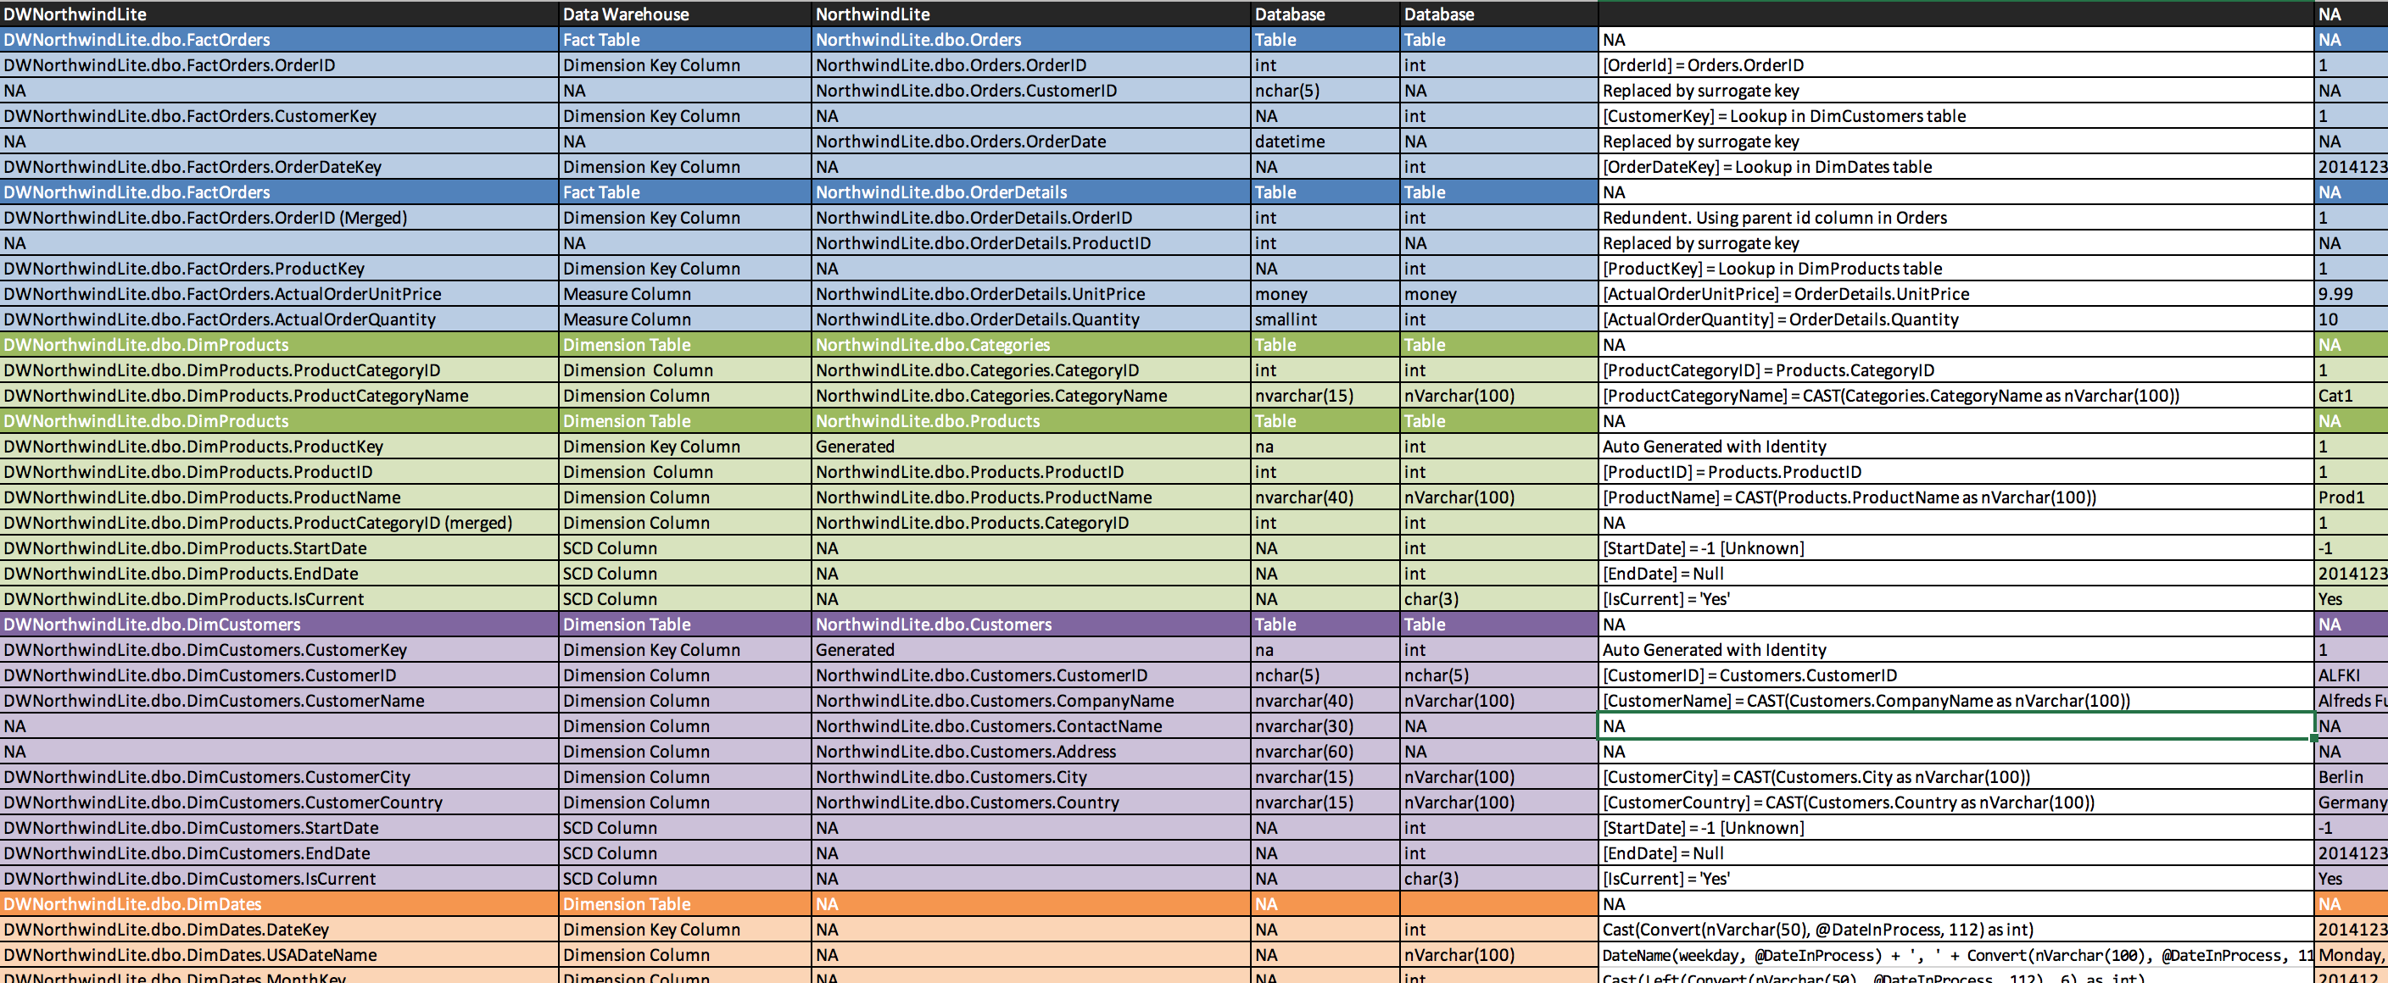

As creating a such excel spread sheet, it would help me to shaping and creating ETL script for the assignment. I was somewhat wondered how to connect dimDates to OrderDate on the Fact table. There were two ways to get OrderDateKey on the Fact Table. One was to transform the form of OrderDate into int value and to connect the value with DimDates.DateKey. Another was to make another Date column on the DimDate to connect with OrderDate. For this time, I chose first way. After finishing the excel sheet and adding Date column on DimDates in the created OLAP data warehouse, as you can see the picture as shown below, I started to create an actual ETL script for the assignment with the ERD of DWNorthwindLite.

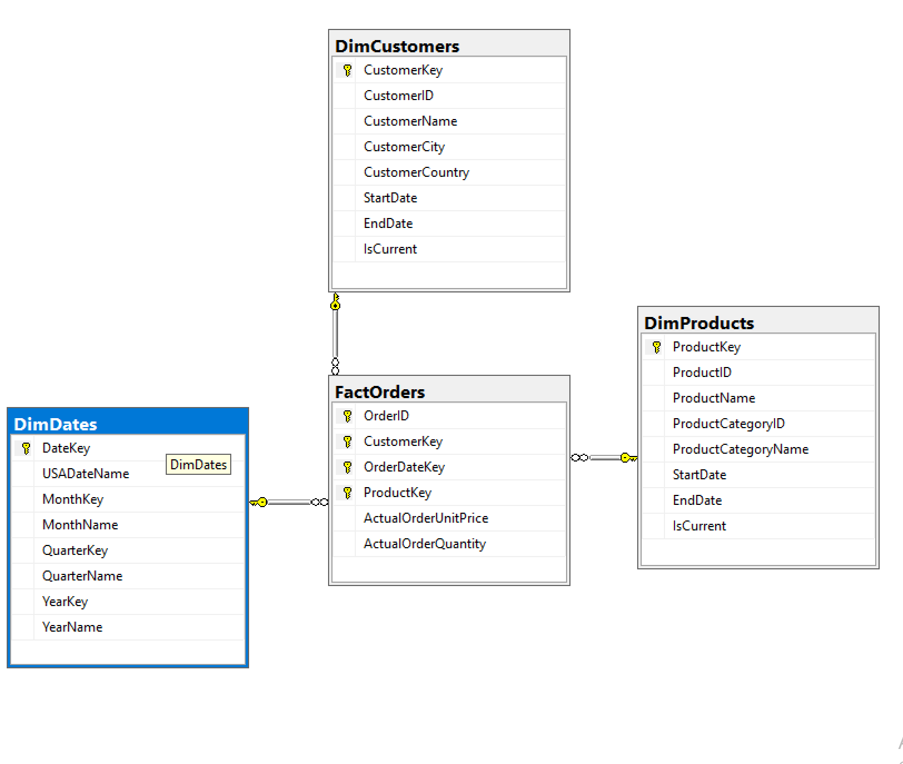

For the process of creating an actual ETL script, there are few steps:1. Drop the foreign keys constraints, 2. Truncate tables, 3. Fill the tables, 4. Re-create the foreign keys, and 5. Review the works.

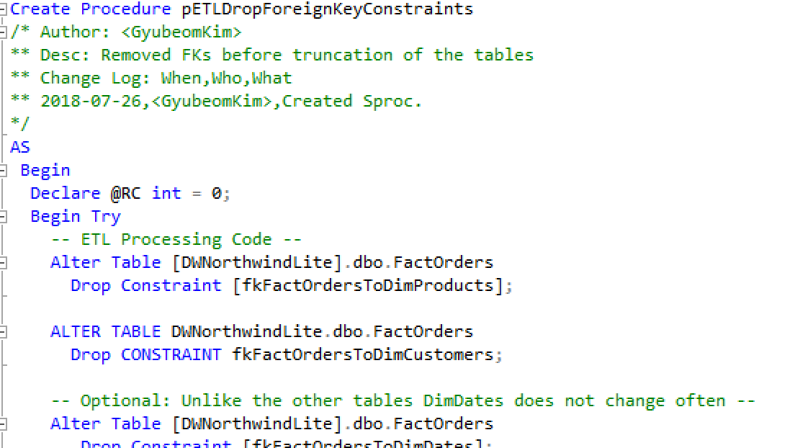

**Drop the foreign keys constraints (Code Picture shown above)**

For clearing the tables, we have to drop the foreign keys constratins for avoiding the errors. Without doing it, we cannot create the table. Then, I was able to do next step.

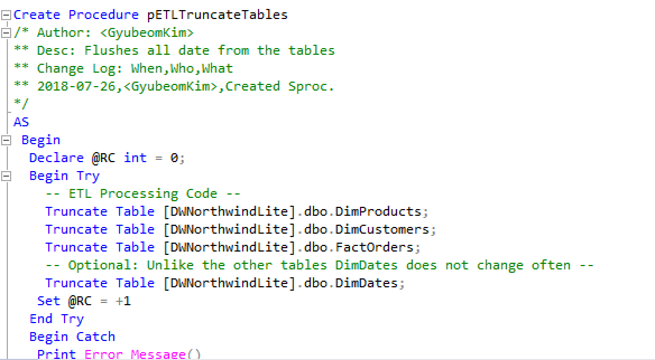

**Truncate tables (Code Picture shown above)**

In this procedure, I simply truncated tables. Actually, there are two ways to clear the table out by clrearing data. In the data warehouse of a SQL, we can either use the DELETE and TRUNCATE. For this process, TRUNCATE is more efficient because it is faster. Also, when we creates new data , the row of data starts with ‘1’ after using it. However, if you use DELETE for 4 rows, the data row starts with ‘5’.

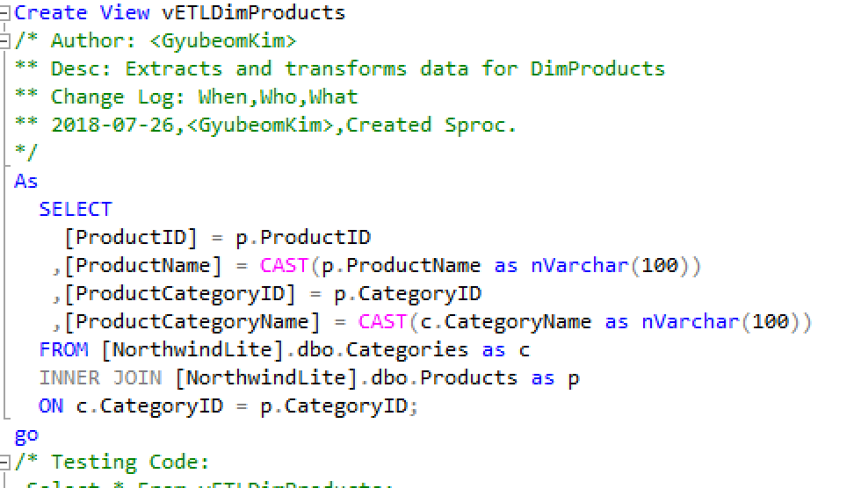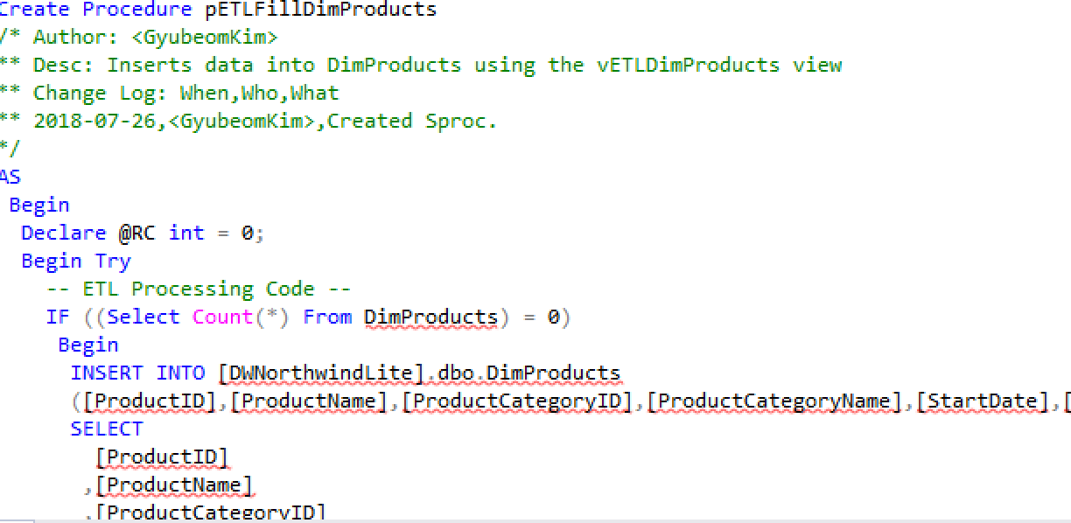

**Fill the tables with Views (Code Picture shown above)**

In this process, I used views before filling the data into the tables. There are few advantages using views for filling in the data;we can avoid the complexity of programming statements by binding these statements to a named object and duplication of data structures (Root, 2018).

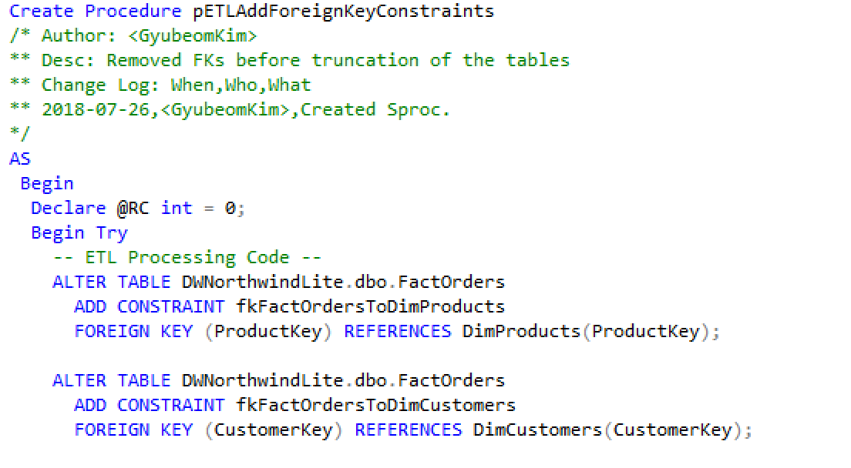

**Re-create the foreign keys** **(Code Picture shown above)**

In this process, I just simply re-created foreign keys.

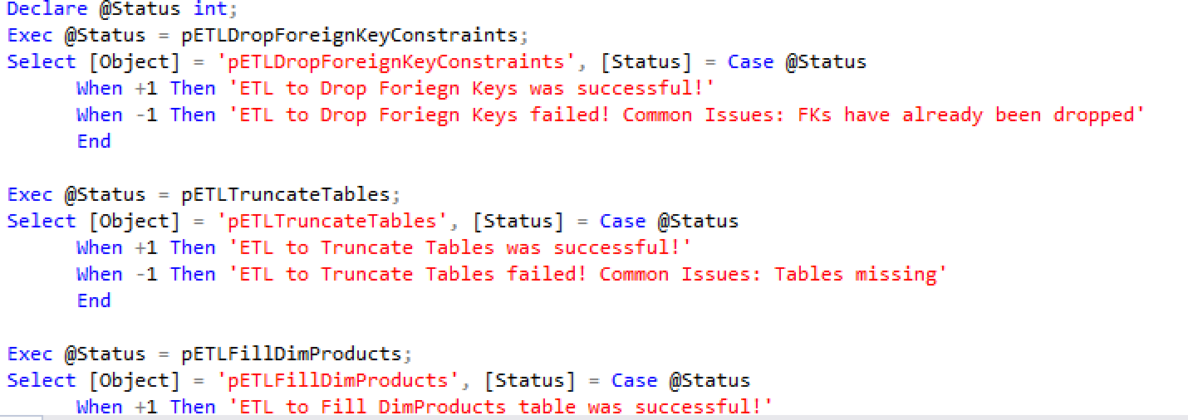

**Review the works** **(Code Picture shown above)**

For checking and reviewing all the above processes, I created such codes.

**Details (Steps for ETL Process):**

**Drop the foreign keys constraints**

-Alter Table [TableName] Drop Constraints [ConstraintsName]

-Dropped three constraints that connected with Fact table.

**Truncate tables**

-Truncated Table [TableName]

-By using Truncated, cleared all data from three dimensional tables and one fact table.

**Fill the tables with Views**

-Created views before filling data into table, and stored procedure for all tables

EX) Created View [Name]

As Select [Column = CAST(…), ] From [TableName]

Created Procedure [Name]

INSERT INTO [Column,…] SELECT FROM [View]

-added code for checking for the cleared data table

EX) IF ((Select Count(*) From TABLENAME) = 0)

**Re-create the foreign keys**

-Re-created three foreign keys that are dropped.

EX) ALTER TABLE DWNorthwindLite.dbo.FactOrders

ADD CONSTRAINT fkFactOrdersToDimProducts

FOREIGN KEY (ProductKey) REFERENCES DimProducts(ProductKey);

**Review the works**

-Created a script that tells whether all the processes is successful or not.

-Changed status number to the messages.

EX) Declare @Status int;

Exec @Status = pETLDropForeignKeyConstraints;

Select [Object] = 'pETLDropForeignKeyConstraints', [Status] = Case @Status

When +1 Then 'ETL to Drop Foriegn Keys was successful!'

When -1 Then 'ETL to Drop Foriegn Keys failed! Common Issues: FKs have already been dropped'

End

**Work Cited**

Root, R. (2018). *Module2*